Name _______________________________ Hour __________

**BELL ASSIGNMENTS** MAY You need to copy the question off of the board next to the date and then below it write your response. I expect you to spend a minimum of 3 minutes of these in order to receive full credit.

**05/04:**

**As we near the end of the story, what are your predictions as to how the story will end? Explain in detail.**

**05/05:**

**Anne's last lines of her diary are, "In spite of** **everything, I still believe that people are really** **good at heart." Do you believe in Anne's conclusion? Why or why not?**

**05/06:**

**Tell about a time when you treated someone differently. What was it that made you decide to do that? What was the outcome? OR tell about a time when you were treated differently for something you couldn't control. Explain.**

**05/07:**

**First impressions are often very important.**  **Describe a time you got (or gave) the wrong** **impression. What was the result?**

**05/08:**

**Look at the picture below and write a caption** **for it. Explain why you picked the caption that you did.**

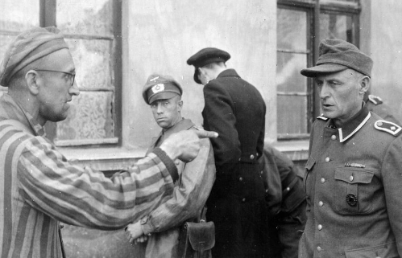

**05/11:**

**It has often been said that there is nothing to fear but fear itself. Describe a time when you overcame one of your fears? What was it? How did you feel?**

**05/12:**

**If you could be invisible for one day, what would you do? Why would you do that?**

**05/13:**

**People often say, "What you don't know won't hurt**

**you," but the opposite often turns out to be true. Tell**

**about a time when you were hurt by something that**

**you didn't know.**

**05/14:**

**What type of writing do you think is the easiest to do?**

**FIVE PARAGRAPH STRUCTURED writing (expository,**

**research,persuasive, descriptive) OR CREATIVE writing**

**(writing that has emotions and feelings and not just**

**presents facts)**

**05/15:**

**People of all ages make contributions to the world. Do you agree with this statement? Why or why not? Do you think you have made any contributions yet?**

**05/18:**

**Write a scene or story that includes these three elements: An ex-friend, a fake illness, and a party invitation.**

**05/19:**

**It's your character's first day at a new school. He or she wants to get a fresh start, develop a new identity. But in his or her homeroom, your character encounters a kid he or she knows from summer camp... START WRITING ☺**

**05/20:**

**My hair stood on end, a shiverraced down my spine and a lump came to my throat.**  **It was him...CONTINUE WRITING ☺**

**05/21:**

**The phone rang. "Hello," I said, "Hello." No one was there.  I hung up.**  **All the lights went out...CONTINUE WRITING ☺**

**05/22:**

**It was spring 2014 when I first**

**realized I could breathe under water…**

**05/26:**

**Footsteps slowly creaked on every step of the stairs. The bedroom door handle turned slowly…CONTINUE WRITING ☺**