**Name______________**

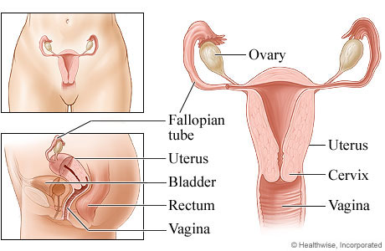**Fill in the FEMALE reproductive ANATOMY**

**Explain the major FEMALE reproductive anatomy FUNCTIONS**

**1. Ovary-**

**2. Fallopian tube-**

**3. Uterus-**

**4. Cervix-**

**5. Vagina-**

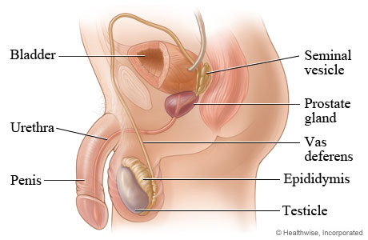**Fill in the MALE reproductive ANATOMOY**

**Explain the major MALE reproductive anatomy FUNCTIONS**

**1. Scrotum-**

**2. Testicle-**

**3. Epididymis-**

**4. Vas deferens-**

**5. Prostate gland-**

**6. Seminal vesicle-**

**7. Bulbo urethra-**

**8. Urethra-**

**9. Penis-**