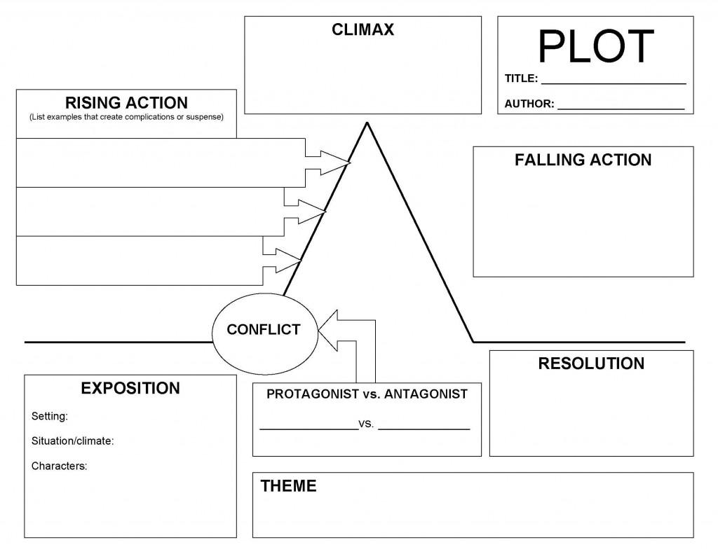**Creating Suspense: Foreshadowing**

**LT:** I can analyze the plot in order to gather textual evidence that demonstrates where and how the author creates tension and suspense.

1. What is foreshadowing?

2. Find three quotes from the story that foreshadow an event from later in the text. Explain what both of these quotes foreshadow.

Quote #1:

This foreshadows…

Quote #2:

This foreshadows…

Quote #1:

This foreshadows...