**“Slip or Trip?”- Supporting Interpretations of Evidence**

Name:________________________________

LT: I can support my interpretation of evidence with a general rule (warrant).

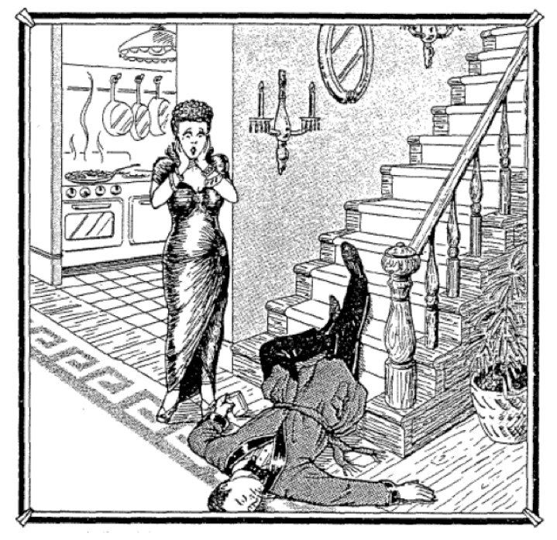

At ﬁve-feet-six and a hundred and ten pounds, Queenie Volupides was a sight to behold and to clasp. When she tore out of the house after a tiff with her husband, Arthur, she went to the country club where there was a party going on.

She left the club shortly before one in the morning and invited a few friends to follow her home and have one more drink.

They got to the Volupides house about ten minutes after Queenie, who met them at the door and said, “Something terrible happened. Arthur slipped and fell on the stairs. He was coming down for another drink—he still had the glass in his hand—and I think he’s dead. Oh, my God—what shall I do?

The autopsy conducted later concluded that Arthur had died from a wound on the head and conﬁrmed that he’d been drunk.

|  |
| --- |
| Group Work Assignment on Evidence and Rules |
| Your group is an investigative team that must determine what may have happened. You can either agree or disagree with Queenie’s version.    1. Do you think Queenie is telling the truth?  2. Find all the evidence you can that indicates whether or not Queenie is telling the truth. Make a list of all the evidence. Evidence includes concrete, observable information; personal testimony; written documents; and material objects and their condition or experience.  3. Next explain how each piece of evidence supports your claim that Queen is or is not telling the truth. Each explanation will be generally accepted as rule, which may begin with a phrase such as, “As a rule….” If other members of your team disagree with you, find evidence that will convince them.  4. Be prepared to explain why your evidence supports your case. Eventually you will each write a report to convince the others in the class that your analysis makes the most sense. |

|  |  |  |
| --- | --- | --- |
| Evidence | Rule (Warrant) | Conclusion |
|  |  |  |
|  |  |  |
|  |  |  |
|  |  |  |
|  |  |  |
|  |  |  |

**Write:** Now, write a paragraph that explains the evidence and the general rules (warrants) used to support your interpretation of the evidence. You must use at least five pieces of evidence, each with the rule (warrant) and necessary explanation.