**Identifying Main Idea & Supporting Details**  Name:________________________

**Learning Targets:**

* I can define the different types of supporting details.
* I can determine what the main idea is of an article, locate supporting details used to develop the main idea.

**Directions:** We will read the following article in order to identify the main idea and the supporting details. Answer the questions below in complete sentences.

**Part 1: Identify the Main Idea**

Step 1: Read the Title--What is this article going to be about and what information do you think we will get in this article?

Step 2: Read the first paragraph (introduction)-- What information have we been given so far about the topic? What sentence or two do you think best expresses the main idea of this article?

Step 3: Read the Passage

Step 4: Express the main idea of the article in your OWN words using complete sentences. (Write in the graphic organizer provided)

**Part 2: Identify Supporting Details**

Step 1: Read the article again, this time, looking for supporting details that help us understand the main idea. Identify four supporting details and write them in your graphic organizer.

Step 2: Provide an example of each type of supporting detail in the form of a quote from the article.

Anecdote-

Example-

Fact/statistic-

Description-

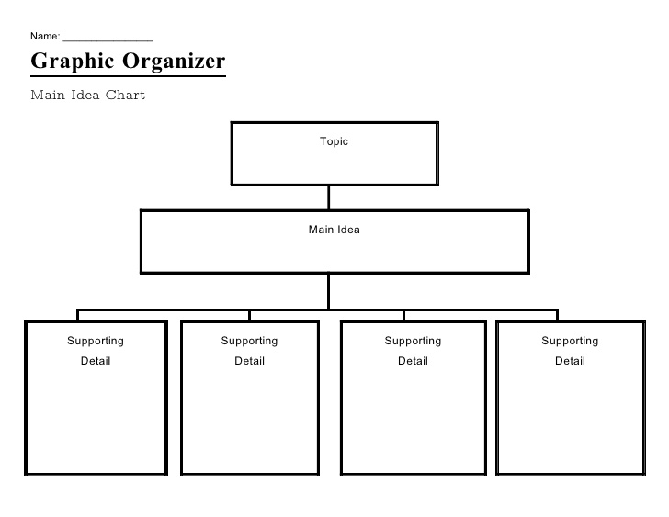

**How Dogs Read Human Body Language**

**Is your dog reading you like a book?**

By Stanley Coren

- See more at: http://moderndogmagazine.com/articles/how-dogs-read-human-body-language/278#sthash.h6nIk0aI.dpuf

Most dog owners have had the experience of simply glancing at where the leash is hanging, only to find that Lassie is now headed for the door in anticipation of a walk. While this seems like an everyday event to dog owners, it has special significance to scientists because of what it indicates about how dogs think. First of all, it shows that dogs have the ability to read human body language. In addition, it shows that dogs feel that our movements and gestures contain important cues as to what will happen next in their world.

For decades, scientists have been studying "social cognition" in dogs. This simply refers to how well dogs read cues in the behaviour of others. As humans, we do this automatically. For instance, we know that when the person we are talking to starts glancing at his or her watch, we had best get to the point quickly. All social mammals have evolved remarkably discriminating ways of reading the signals sent to them by their group members, normally members of the same species. However recent research shows that dogs are surprisingly good at reading certain types of social cues in humans.

The experimental set-up used to test for such perception in animals is quite simple. Start with two inverted bucketlike containers. Place a morsel of food under one of them while the subject of the test is out of sight. Of course you must make sure that both containers have been rubbed with the food so that there is no scent difference. Now bring the subject in and give some sort o social cue to indicate which bucket actually contains the food. The most obvious cue would be to tap the container with the food. Less obvious would be to point your finger toward it. An even more muted signal would be to tilt your head or body toward it without pointing. The subtlest signal of all would be not to move your head or body but to simply look with your eyes toward the correct container. If the subject chooses the right container he gets the food. Simple, huh? Don't bet on it.

Surprisingly, Daniel J. Povinelli, a psychologist at the University of Southwestern Louisiana, found that our closest animal relatives, chimpanzees, were initially quite poor at this task. (Actually, so were three-year-old human children, though they were better than the apes.) However, both the chimps and the kids could quickly learn to read the correct cues. The real surprise came when a team led by Robert Hare of Harvard University ran the same test on dogs. The dogs could immediately interpret the signals indicating the location of the food four times better than the apes, and more than twice as well as the young children, even if the experimenter was a stranger.

Now the real question is: where did dogs get this talent? The first guess might be that since dogs are descended from pack-hunting wolves, the ability to pick up social signals evolved to help coordinate the hunt. If so, one would imagine that wolves should be at least as good at the bucket task as dogs. However when Hare tested wolves at the Wolf Hollow Wolf Sanctuary in Massachusetts, he found that they were actually worse than chimpanzees and a lot worse than dogs. The next guess might be that dogs learn to read human body language because they hang out with and watch their human families. This would suggest that young puppies, especially those still living with their littermates and not yet adopted into human families, should be poorer at picking up human signals. Wrong again! Even nine-week-old puppies, still living with their mother and littermates, do better than wolves or chimps. "The punch line is that this ability was not inherited from the last common dog-wolf ancestor, and it does not take tremendous exposure to humans," said Hare in a recent conversation.

With the experimental evidence driving wooden stakes through the hearts of the two most obvious explanations, we are still left with the question: where do dogs get their superior ability to read human signals from? Once again we have two candidate explanations, both concerning evolutionary changes that occurred during dogs' domestication.

Obviously, dogs that could figure out their masters' intentions and desires would have been more likely to thrive in a human-dominated environment and hence produce more young. But were specific dogs initially chosen to be domesticated because they had a better ability to understand people? Or was the improved ability some sort of unintended by-product that arose during the process of domestication?

It is easy to find rational reasons to support either of these two theories. Obviously people would tend to prefer and form stronger bonds with dogs that could understand human body language. However the alternative theory could also work. Domestication usually involves selecting the tamest and most easily managed animals-for safety's sake, if nothing else. According to Hare, "If you select against aggression, a whole suite of changes accompanies that reduction in aggression. There are a lot of unintended changes that occur as by-products." In a classic early set of experiments on captive foxes, it was shown that these changes are not just behavioural, but include tendencies toward floppy ears, tails held high, and multi-coloured coats. "So it's possible that this ability in dogs is simply a by-product of domestication. You pick the calmer, more attentive animals, and they also happen to be the ones that are better able to pick up subtle social cues."

Unfortunately the scientific jury is still out. We simply don't have enough data to decide whether humans deliberately chose dogs that could better understand our social signals, or whether this ability is a "hitchhiker" trait that came along on the evolutionary ride to domestication. Regardless, this is yet more proof that our domestic dog is not merely an urban-dwelling wolf that has learned to sport a veneer of civilization in order to get free room and board. Rather, the dog is a separate species that has evolved, or more precisely co-evolved, with humans.

Given the fact that we started this discussion with every dog owner's presumption-as an article of faith and observation- that our pet dogs understand our body language and signals, I simply could not end my interview with Hare without asking, "Won't dog people think that this research finding is obvious?"

"I had the same reaction," he replied. "I knew that people would say, ‘Of course dogs understand this kind of thing!' But it's one thing to say it and another to go and demonstrate it. The people who were really surprised were the scientists-not the lay people." ■

*Stanley Coren is Professor of Psychology at the University of British Columbia and author of several books on dogs, including How to Speak Dog and Pawprints of History. His website is* [*www.stanleycoren.com*](http://www.stanleycoren.com/)*.*

- See more at: http://moderndogmagazine.com/articles/how-dogs-read-human-body-language/278#sthash.h6nIk0aI.dpuf