Tracking Plot Name:________________________

**Learning Target:** I can identify the elements of a plot diagram in a piece of literature.

**Directions:** Below, you will track the plot of “The Sniper” (Pg. 262). Using the text and guidance from me, you will identify the setting, characters, plot events and theme. As I instruct us in what each of these elements are, you must be taking notes so you can use the definitions to support your responses.

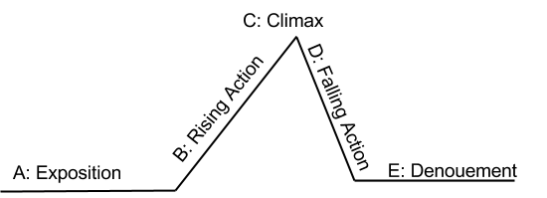

|  |
| --- |
| **Exposition**  Setting: Where and when does this story take place? What details does the author provide?  Characters: Who are the characters? Which character is the protagonist and which is the antagonist?  Conflict: What is the protagonist up against? What type of conflict is this and is it internal or external?  Point of VIew: What perspective is this story told in? How do you know? |

|  |
| --- |
| **Rising Action**  What events pose problems for the protagonist while facing the conflict? What actions did they take to resolve these problems?  Event #1-  Resolution-  Event #2-  Resolution-  Event #3-  Resolution- |

|  |
| --- |
| **Climax**  At what point in the story does the conflict seem to be coming to an end, where you may know what will happen next? What specific event leads us to think that the conflict will now be resolved? |

|  |
| --- |
| **Falling Action**  What are the character’s feelings or emotions after the turning point of the story? Does the character feel like he has resolved the conflict? What does he/she do after the climax? |

|  |
| --- |
| **Denouement (Resolution)**  How does the story end? Is the original conflict solved? Does the story end with any new conflicts? |

|  |
| --- |
| **Theme**  What does the reader learn from this story? What is the central message that the author wants to get across? |

**Summarizing the Plot:**

Now that you have identified elements of the plot diagram in the story, you will summarize the whole story below in a paragraph. Your paragraph must cover all five stages of the plot diagram.

____________________________________________________________________________________________________________________________________________________________________________________

____________________________________________________________________________________________________________________________________________________________________________________

____________________________________________________________________________________________________________________________________________________________________________________

____________________________________________________________________________________________________________________________________________________________________________________

____________________________________________________________________________________________________________________________________________________________________________________

____________________________________________________________________________________________________________________________________________________________________________________

______________________________________________________________________________________________________________________________________________________________________________________________________________________________________________________________________________