Agenda
Crooked Lake PTO
Tues. Dec. 19, 2017, 6:30pm
Crooked Lake Elementary Computer Lab

1. Call to Order
-- Introductions/ Sign in

2. Officers’ Reports
-- Gretchen Jerskey, Chair
- Movie Night recap
- Working on open gym event with Community Ed
-- Trish Gunville, Secretary
- Review/Approve minutes from Nov. Meeting
-- Amie Beckel, Treasurer
- APEX – final tallies
- Fundraising meeting Thurs. Jan. 18, 7pm in the media center – getting the word
out, no childcare (students’ input requested, refreshments provided)

3. Staff Reports
-- Sam Anderson, Principal
-- Julie Petersen, Administrative Intern
-- Teachers
-- Candie Hansen, Volunteer Coordinator
-- Robyn Hjorth-Martin, Social Worker
(student council mitten drive, jump rope for heart planned)

4. New Business
Funding Requests:
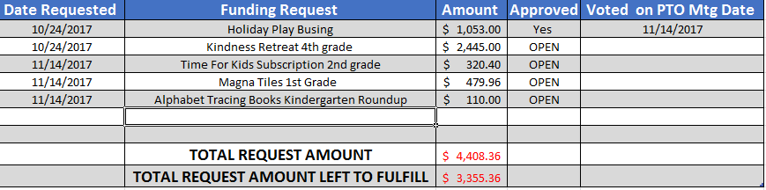
-- Other new business

5. General Discussion/ Announcements/ Upcoming events

6. Adjourn

Upcoming PTO-Sponsored Events
TBD – Open gym on a Saturday morning in February (for discussion)
Wed. Feb. 21 – Staff appreciation dinner during conferences
Sat. Apr. 7 – Spring Carnival

